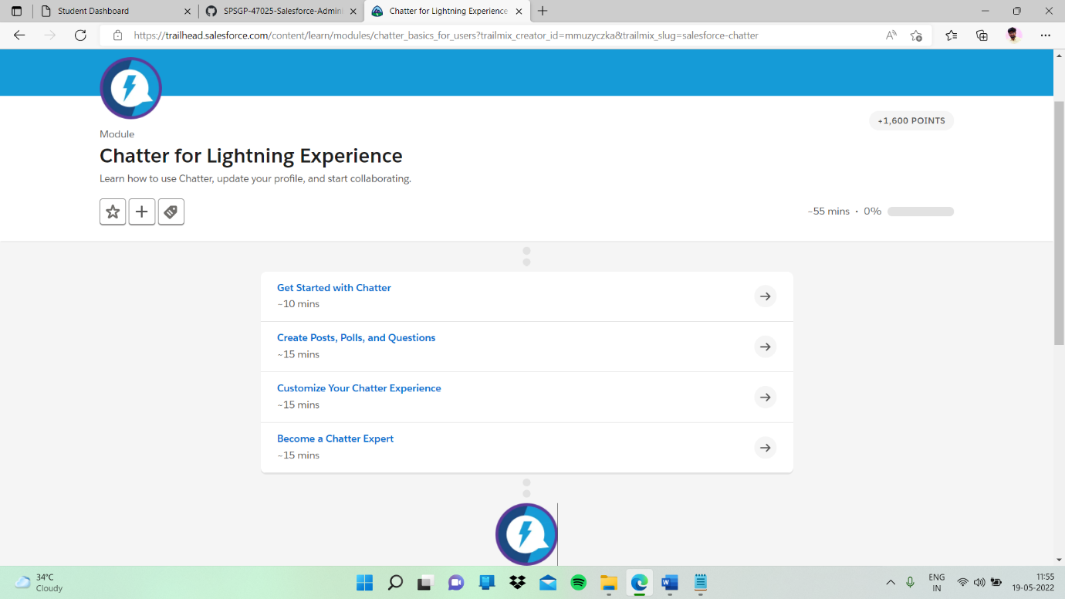

Sub topic:- Create Posts, Polls, and Questions

In this my task

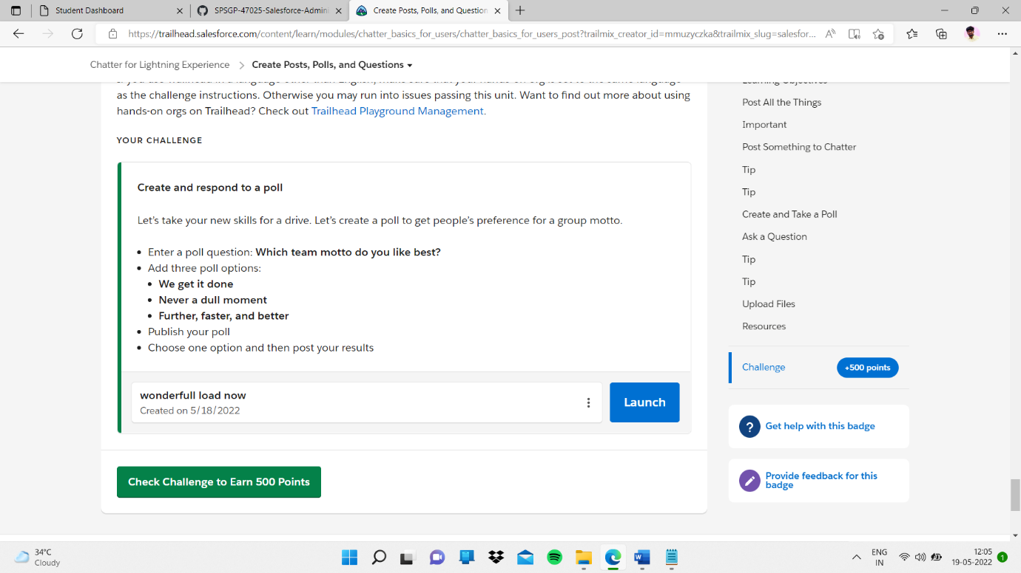

I clicked launch button

In thjs I created a poll and finished

